Supplemental figures
Figures S1-S6
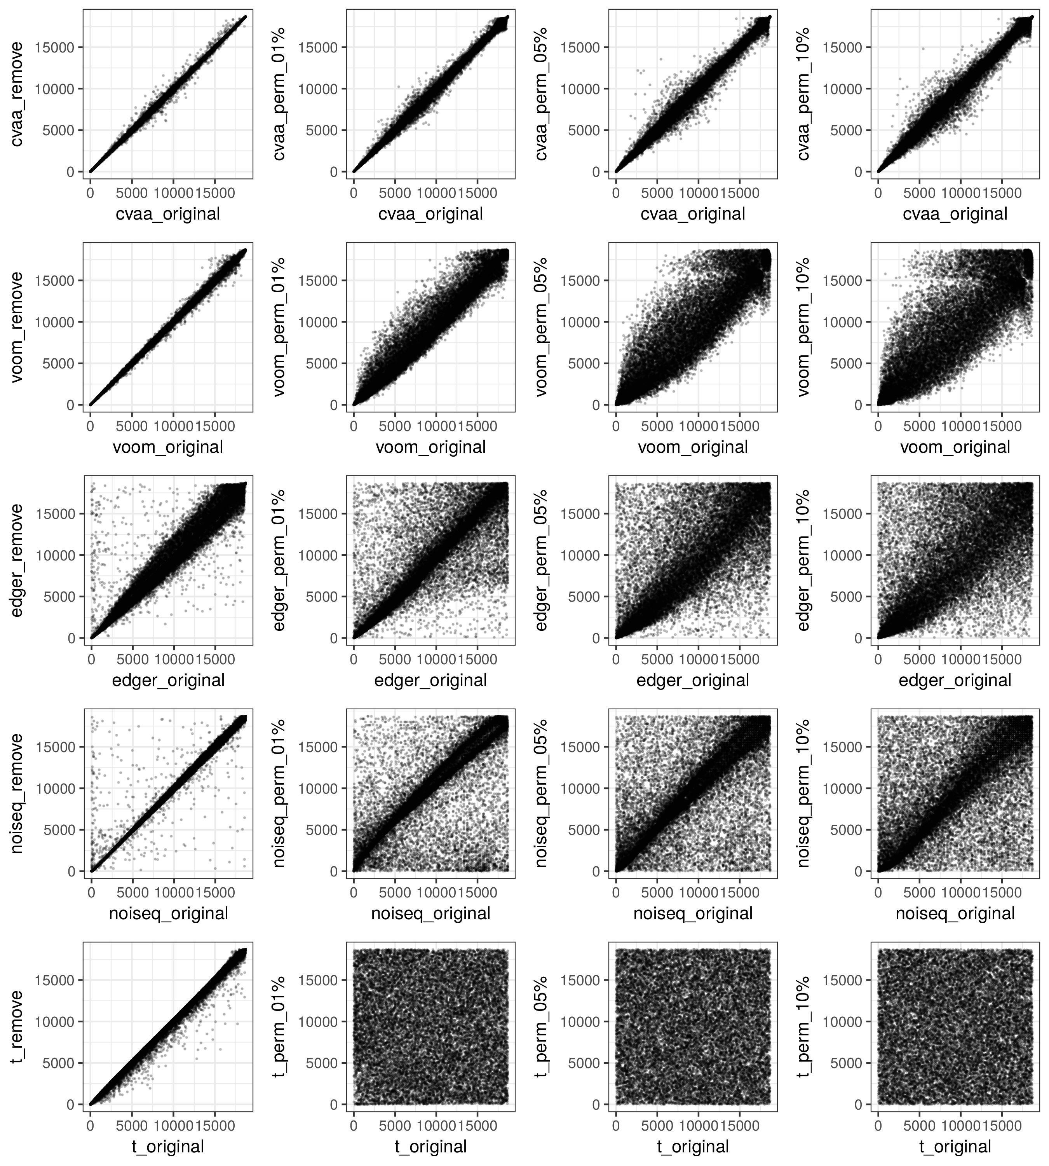
Fig S1. Differentially expressed gene rank changes. Original: data without modification, remove: an outlier sample was removed (TCGA-GI-A2C8-11A-22R-A16F-07), perm: the gene labels in a fraction of samples were permutated.

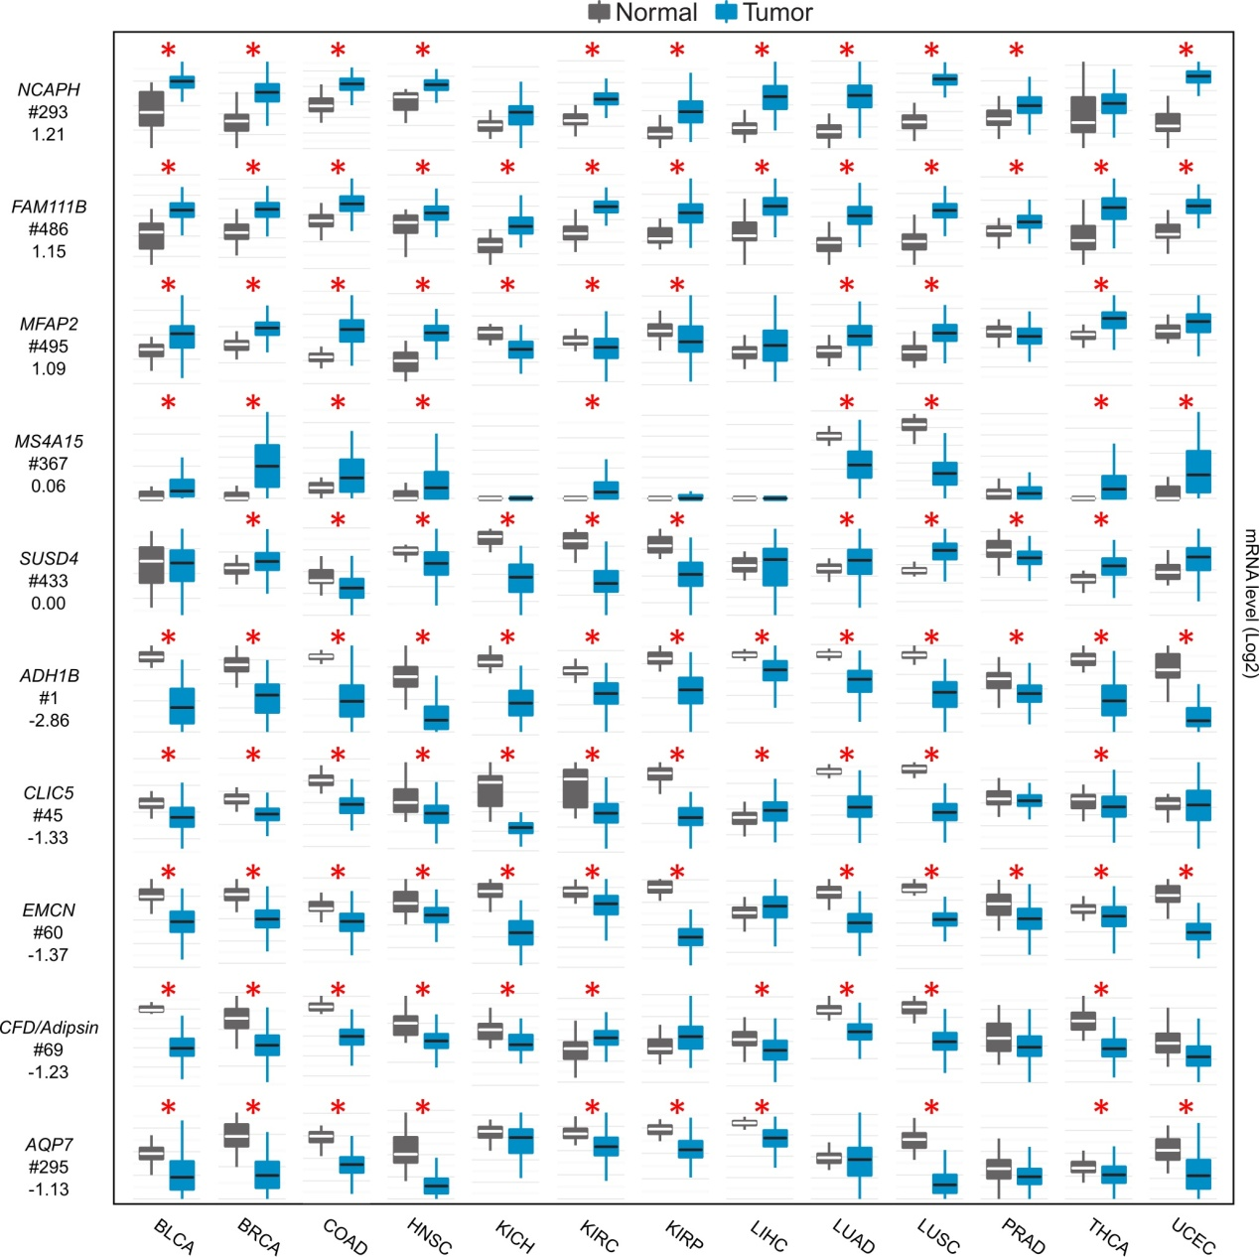
Fig S2. Expression difference of the 10 selected genes for functional assay between normal tissues and tumors across the 13 cancer types. Each row in the first column indicates gene symbol, rank number and LOD value, respectively. Y axis of mRNA levels is log2 scaled. *P < 0.0001 (Student’s t-test, Table S5).

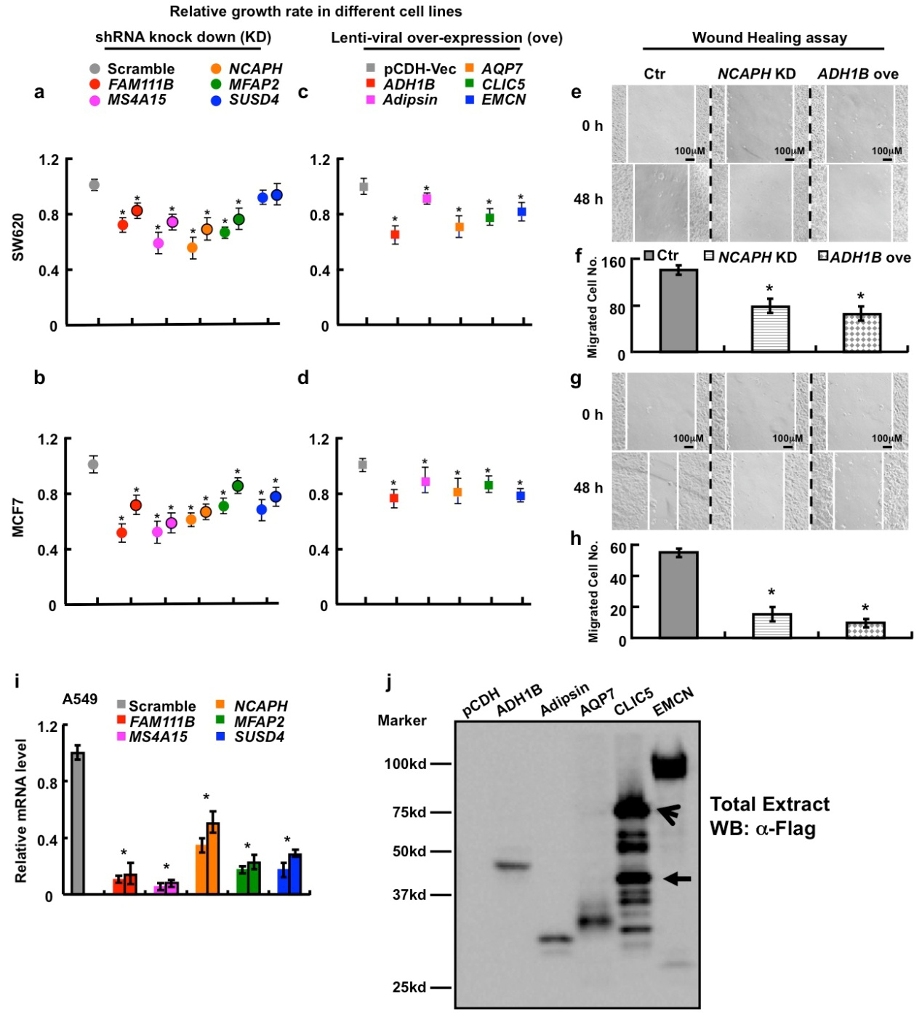
Fig S3. Functional study of 10 picked genes from the top 500 gene list in SW620, MCF-7 and A549 cell lines. (a-b) 3 up-regulated genes: FAM111B, NCAPH and MFAP2, and 2 cancer-specifically dysregulated genes (MS4A15 and SUSD4) were inhibited by 2 independent shRNAs targeting to different gene regions (indicated by different colors with or without black circle), respectively, stable cells were selected by puromycin. Different tumor cells were trypsinized and plated into 24-well plates and the cell numbers were subsequently counted at each day. Here, representative day 4 cell numbers normalized to scramble shRNA or pCDH-Vec control cells which have the same growth curve (considered as:1) were shown to make the data distinguishable, *P < 0.05. (c-d) 5 down-regulated genes: ADH1B, Adipsin, AQP7, CLIC5 and EMCN were over-expressed, respectively, stable cells were also selected by puromycin and the cell numbers were counted and compared the same as in a-b. The error bars represent the SEM of triplicate experiments, *P < 0.05. (e, g) Representative wound healing assay using indicated cancer cell lines at 0 or 48 hours, respectively. (f, h) Representative trans-well cell migration assay using indicated cell lines at 48 hours, 5 regions under microscopy were randomly picked and the total cell numbers were counted, *P < 0.05 compared to the control (scramble shRNA or pCDH-Vec). (i) Relative mRNA expression level of indicated genes normalized to the sramble shRNA control (considered as: 1) was quantified by qRT-PCR, *P < 0.05. (j) A549 cell lines stably expressing indicated Flag-tagged genes were collected, total extracts of indicated cell lines were probed with Flag antibody. The open arrow points to the dimerization form of CLIC5, whereas the closed arrow points to the tagged-monomer form of CLIC5. All the experiments were repeated at least 3 times, representative images were shown.
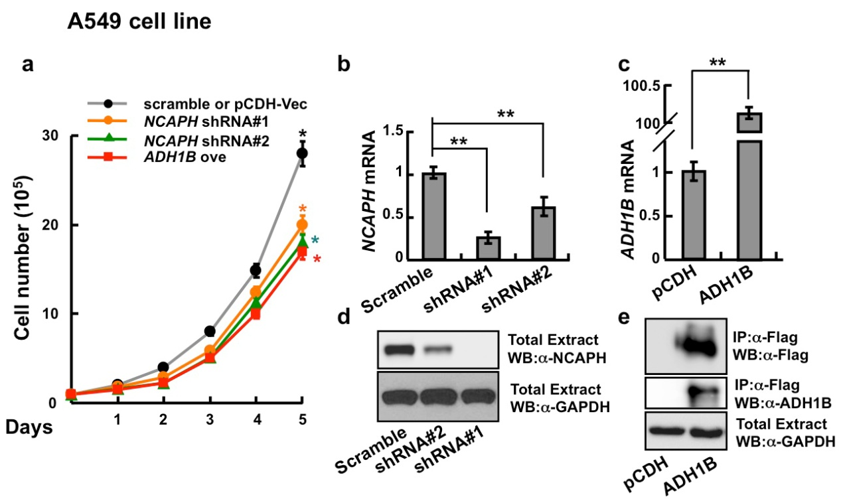
Fig S4. Depleting NCAPH or over-expressing ADH1B inhibit A549 cell proliferation. (a) Scramble shRNA and pCDH-Vec stably expressing A549 cells have the same proliferation rate, however, inhibiting NCAPH with 2 independent shRNAs or over-expressing ADH1B markedly restrain cell proliferation. The error bars represent the SEM of triplicate experiments. *P < 0.05, Student’s t-test. (b) The knock down efficiencies of 2 independent shRNAs against NCAPH were verified by qRT-PCR. **P < 0.01, Student’s t-test. (c) The transcription level of ADH1B was dramatically increased by lenti-viral expressing Flag-tagged ADH1B. **P < 0.01, Student’s t-test. (d-e) The antibodies against NCAPH or ADH1B for IHC were verified by western blot. Cell lysates or immunoprecipitated samples were probed by indicated antibodies, respectively. All the experiments were repeated at least 3 times, representative images were shown.

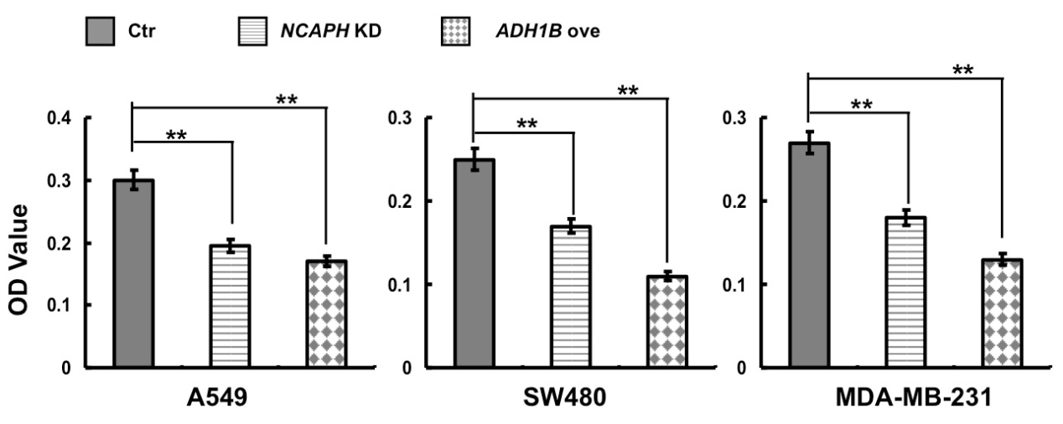
Fig S5. Quantification data for trans-well data shown in Figure2j, 2l, 2n. The OD values were counted and shown. **P < 0.01, Student’s t-test.

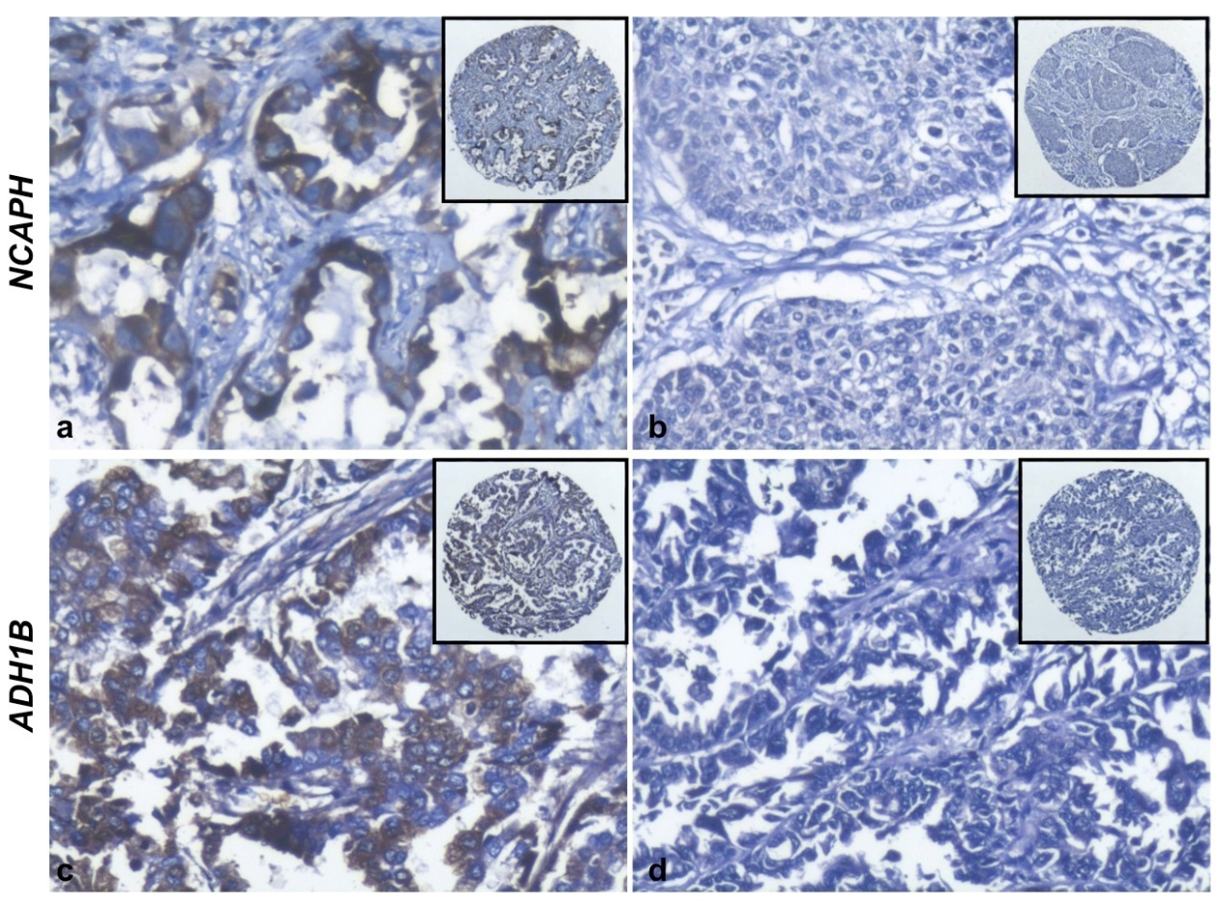
Fig S6. IHC results for NCAPH and ADH1B in NSCLC. (a-d) IHC, DAB staining, 200X. (a) Strong positive expression of NCAPH was identified on cytoplasm and nuclear of lung cancer tissue. (b) Tissue sections using PBS as negative control showed no positive staining of NCAPH in the lung cancer tissue (c) Strong positive expression of ADH1B protein was mainly located on cytoplasm of lung cancer tissue. (d) Tissue sections using PBS as negative control showed no positive staining of ADH1B in the lung cancer tissue. The antibodies were verified and representative images were shown.

